# CIT 325 - W03 Office Hours Notes

* Bro. Hinckley’s pseudo code:
  + DECLARE

TYPE three_type IS RECORD

(xnum number,

)

Lv_three_type three_type;

Lv_input_1 VARCHAR2(100);

Lv_input_2

Lv_input_3

TYPE list IS TABLE OF VARCHAR2(100);

Lv_input list;

BEGIN

Lv_input_1 := ‘&1”;

lv-input := list(lv_input1, lv_input_2, lv_input_3, );

FOR LOOP

IF digit

Kv_three_type.xnum := lv_input(i);

Elseif

Alnum

Elseif

Date verify_date

End loop;

Dbms_output

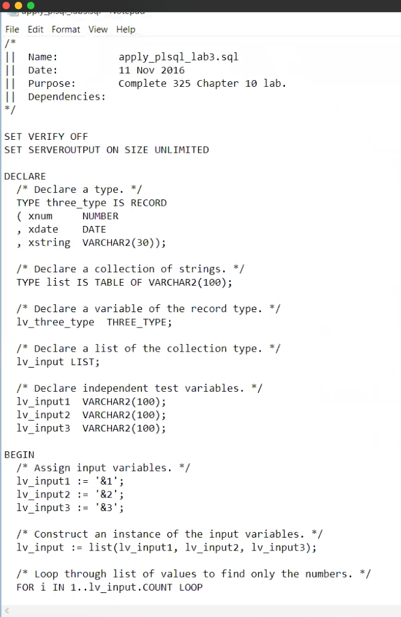

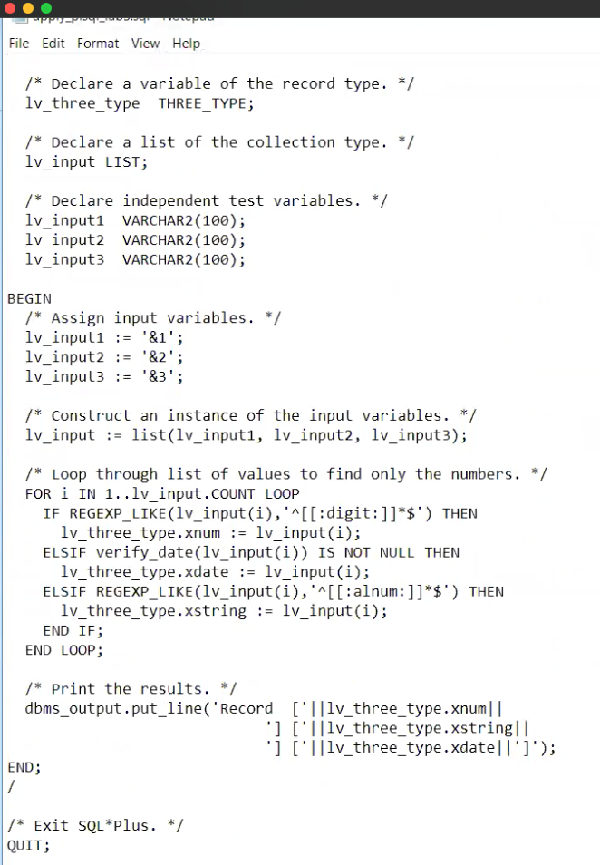

* As for the presentation, we need only choose a topic or a theme in this week’s reading and present it in either PP with voice over or not, a Word document, or whatever we want as long as it has content.
  + 3 to 5 minutes max.
  + Keep it simple,